1. **FILE PUSH**

**STEP 1:** Open git from the directory you want to clone

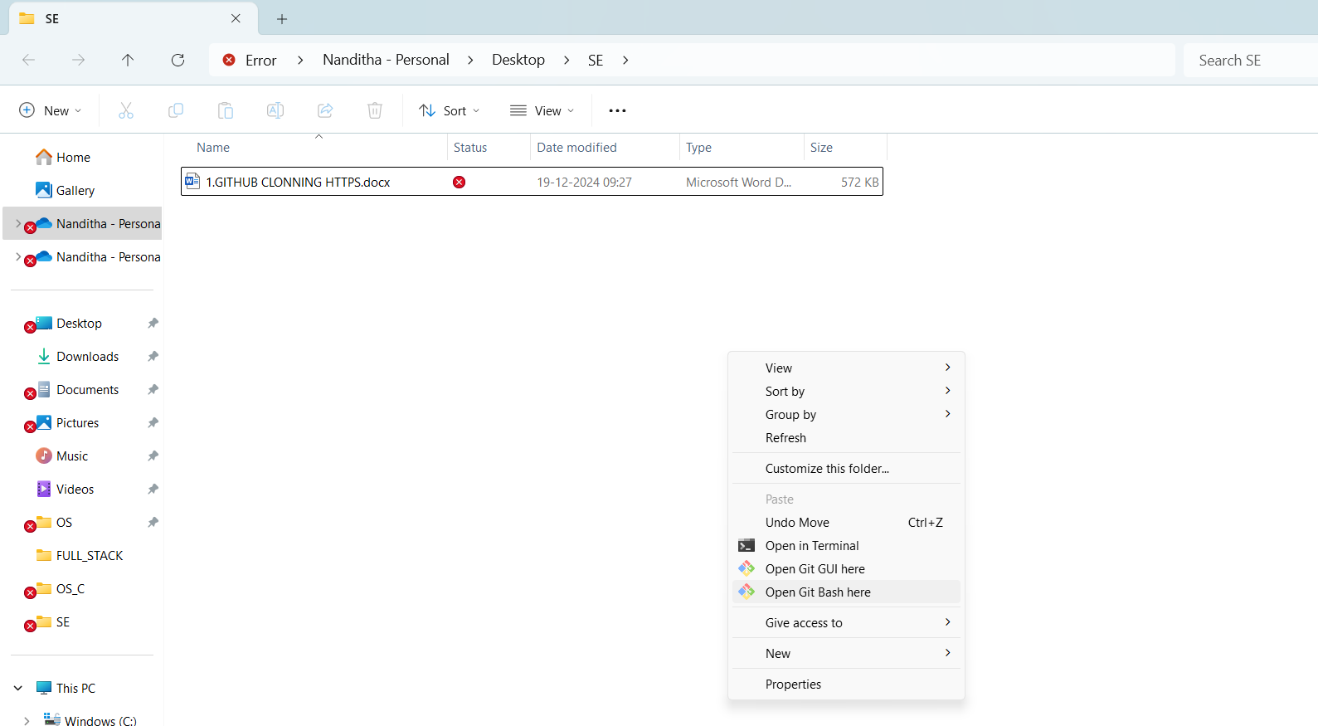



**STEP 2: type git init to initialize**

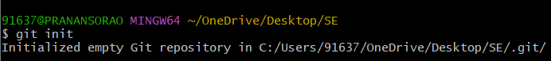

Step 3: open the github and create a repository, if already created type git remote add to add the remote repository by https link



Step 4: open git and type git status

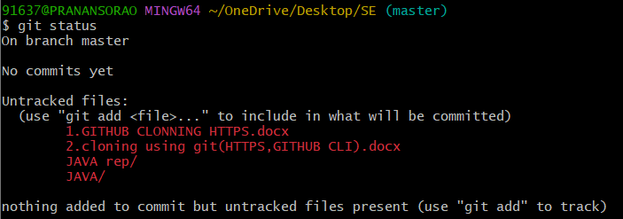

Step 5: input a content into a txt file to do push operation using echo.



Step 6: add the txt file to ready state using git add.



Step 7: commit the status by git commit -m

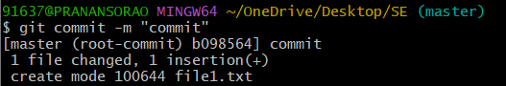

Step 8: check origin

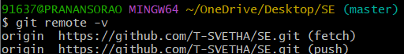

Step 9: Push file into master

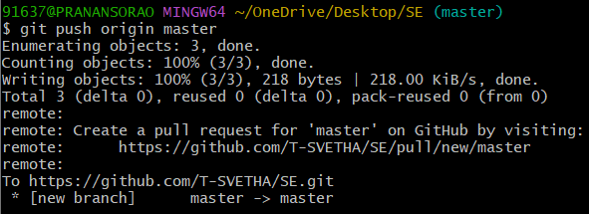

Step 10: check repo for file

